EE 97 Fall 2016

Thursday 1330

Lab #1: Characteristics of a Practical DC Source

Sidarth Shahri

Partner: Christian Lopez

Station 10

submitted 1 September 2016

Lab #1: Characteristics of a Practical DC Source

**Experiments #1-2**

Resistors are labeled with multiple bands of color to indicate their resistance value. Each color corresponds to either a specific digit or multiplier depending on its location. The first two color bands on a resistor express the first and second digit of the value respectively. The third color band indicates the multiplier. The final color band indicates the tolerance of the actual value of the resistor. We measured the actual resistance value of four random resistors and compared it to the indicated value. We then calculated the deviation of the resistor from its actual value and reported it to be within its color range or not.

Measurements of the resistance value were made in ENG 245 Station 10 on Thursday, 25 August 2016 using:

* Elenco Resistance Color Code
* Agilent 34405A 5.5 Digit Multimeter

The resistors came from the provided EE 97 Lab Parts Kit

The circuit was constructed as follows: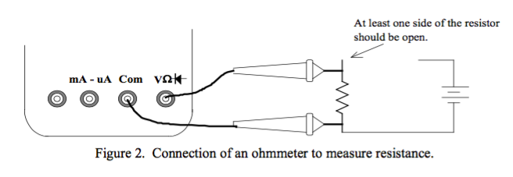

Data was taken as follows:

|  | Colors | Nominal Resistance (Ω) | Tolerance (%) | Measured Resistance (Ω) | % Difference (%) | Power Rating (W) |
| --- | --- | --- | --- | --- | --- | --- |
| R1 | red red red | 2.2 K | 5% | 2.1499 | 2.28 | 1/4 |
| R2 | green brown red | 5.1 K | 5% | 5.0330 | 1.31 | 1/4 |
| R3 | red black red | 2.0 K | 5% | 1.9605 | 1.98 | 1/4 |
| R4 | red purple red | 2.7 L | 5% | 2.6475 | 1.94 | 1/4 |

ExperimentQuestions:

Experiment 1:

2) The rated tolerance of these resistors is 5% as indicated by the gold band.

3) The power rating of each resistor is 1/4 Watts

Experiment 2:

3) Each resistor falls within it’s respective tolerance.

Resistors are manufactured with a specific tolerance and seem to fall within that tolerance all the time. Possible errors may be due to the measurement tools or resistance in the wires.

**Experiment #3**

Breadboards are unique and ideal prototype circuit boards. They are formatted in such a way to allow power to flow through an entire row or column. This allows for extreme versatilely. This coupled with the many rows on a breadboard allow for circuits of all kinds.

Here is a figure of a typical breadboard: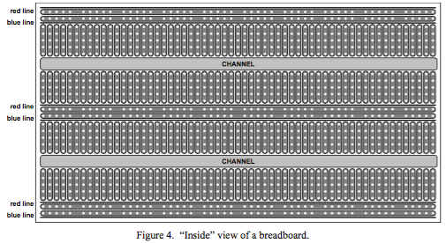

The breadboard used in this experiment was the Breadboard JE26. In this experiment, we examined circuit schematics for their viability. We also constructed a valid circuit from the schematic and measured the total resistance.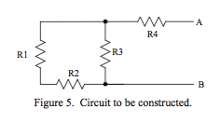

Experiment Questions:

1)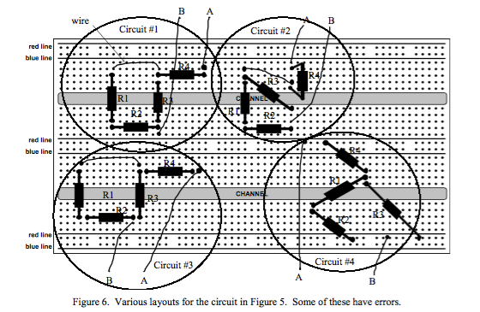

Circuits #2 and #3 have errors. In Circuit #2, R4 is connected across the same row on the breadboard. The current flowing through this circuit will effectively ignore R4. In Circuit #3, R4 is not connected to anything. It is connected to a row that is not part of the actual circuit.

2) The circuit we built and the REQ are shown below.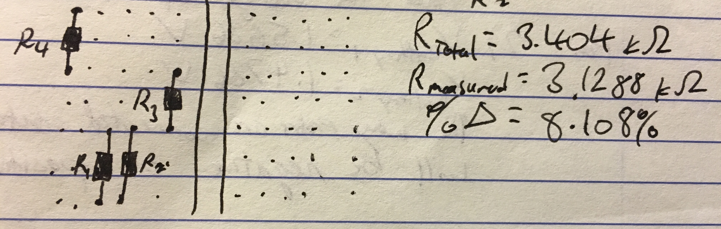

Breadboards are an effective tool for prototyping circuits. The versatility they offer is unparalleled.

**Experiment #4**

The multimeter offers several ways to find voltages, resistance, etc. DCV can be used to find the voltage of batteries. Batteries are constant voltage sources with several benefits. In this experiment, two AA batteries are connected in several ways. The voltage across each battery and both batteries connected in a series are measured to determine the behavior of voltage.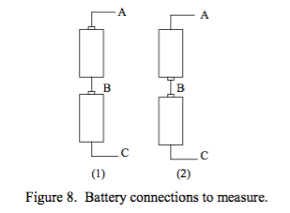

Experiment Questions:

2) The probes order does matter. If the probes are connected with the positive probe at the negative terminal of the battery and the negative probe at the positive terminal, the multimeter displays the voltage as negative. The voltage is positive if vice versa.

|  |  |  |
| --- | --- | --- |
|  | **(1)** | **(2)** |
| **VAB** | 1.5636 V | 1.5636 V |
| **VBC** | 1.4736 V | 1.4736 V |
| **VAC** | 3.0338 V | 86.330 mV |
| **VCA** | -3.0338 V | -86.330 mV |

3)

If two AA batteries are connected in a series in the same orientations, the voltage will be additive. If two AA batteries are connected in a series in varying orientations, the voltage will be reduced significantly.

**Experiment 5**

A battery maintains its voltage unless the current load exceeds its normal operating range. A battery is like a voltage source and a current source. In this experiment, we monitored the voltage of a battery as we gradually increased the load current.

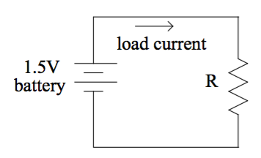

Experiment Questions:

1) V = 1.5636 V

2) V = 1.5626 V with 100 Ω

3)

| Resistance (Ω) | Voltage (V) | Current (A) [V/R] |
| --- | --- | --- |
| none | 1.5636 | 0 |
| **10000** | 1.5625 | 0.00015625 |
| **5100** | 1.5610 | 0.000306078431372549 |
| **1000** | 1.5527 | 0.0015527 |
| **470** | 1.5472 | 0.00329191489361702 |
| **100** | 1.5365 | 0.015365 |
| **47** | 1.5288 | 0.0325276595744681 |
| **22** | 1.5172 | 0.0689636363636364 |
| **10** | 1.4980 | 0.1498 |
| **4.7** | 1.4666 | 0.312042553191489 |
| **2.4** | 1.3266 | 0.55275 |

The greater the resistance, the further the current drops so that a constant voltage can be applied. With less resistance, more current can flow but at a lower voltage. This is proven by Ohm’s law which states that voltage is directly proportional to current and resistance.

**Lab Conclusion**

In this lab, we examined many of the instruments we will be using to conduct experiments throughout the semester. We also observed the voltage properties of simple circuits and constant voltage sources. We also learned how to utilize a breadboard correctly to build and prototype and circuit.